Distribution Factor

Using COURBAN'S METHOD:

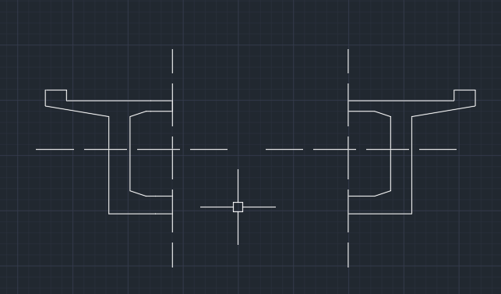

Ri =]

Supposing constant value of I for both sections about the axis:

Ri =]

or,Ri =]

or,Ri =]